# Telegram Update: Now video call with up to 1000 people and many more!

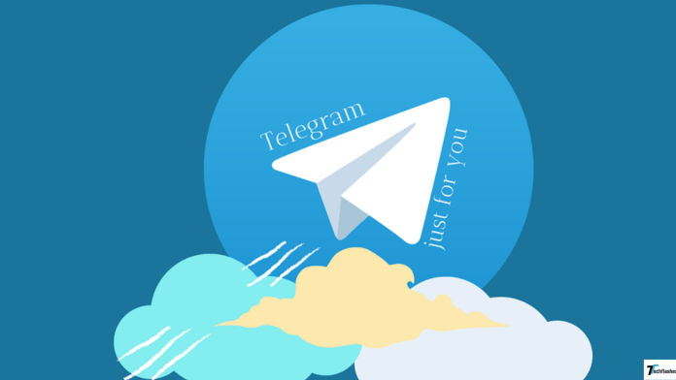

**Introduction**

* *Digitization has made us extremely dependent on our phones and messaging apps our go-to channels for sending instant and quick messages in a fraction of a second. Telegram is one such messaging app that is more than just a messaging app. Like any other app, Telegram keeps updating its features from time to time. One of its features is the video-calling feature which is extensively used by internet users.* [***Telegram***](https://techflashes.com/whatsapp-vs-telegram-vs-signal/)*has updated it recently and now you can video call with up to 1000 people. Along with the video-call update,* [***Telegram***](https://techflashes.com/top-9-telegram-features/) *has come up with a host of other updates.*
* *If your life is dependent on your phone,* [***Telegram***](https://techflashes.com/secure-messaging-apps/) *will help in making it smoothe*r *In this post, we will be covering What Telegram is, its latest update on video calls, and other features.*

## ***What is a Term?***

*Telegram is a quick, simple, and efficient messaging app that can be used on more than one device at the same time. It combines the features of text messages and emails and allows you to write into the contacts on your phone. You can send messages, videos, and photos or conduct voice and video calls. With Telegram, you can create groups with more than 200,000 members. Not only that,* [***Telegram***](https://telegram.org/) *has made broadcasting to an unlimited audience an easy task.*

### **Why is Telegram different from other messaging apps?**

*You might ask, “I use a messaging app already. Why should I switch to Telegram?” Well, we will answer the question in the form of the following points:-*

It allows seamless sync which means you will be able to have access to your messages from more than one device at the same time.

The space occupied by Telegram on your phone is less than 100 MB.

Are you thinking of sending a private message to your friend? Go ahead and send it on Telegram as it is absolutely free.

It is faster and more secure owing to its multi-data center encryption.

### ***Latest Updates on Telegram***

* · The **latest Telegram update** that everyone is talking about is the update for **video calling.** According to it, Telegram now allows 1000 participants to be in a group video call. Till now you could broadcast to 30 users using your camera as well as screens but with the **latest Telegram update,** your broadcasts can be watched by 1000 users. Are you thinking of hosting an online conference or a lecture? Don’t worry! Telegram is here to ease your life. According to Telegram, this limit will keep increasing.
* With the **latest Telegram update**, the quality of video messages has also improved. You can now shoot high-resolution videos and send them across to friends, family members, and acquaintances and even play videos fullscreen.
* While the video plays, audio from the device can keep playing according to the **latest Telegram update** for **video calling.** You can use the zoom-in feature while shooting a video with the rear camera to capture images that are at a distance or to add a dramatic effect to your videos.
* · You can play videos at 0.5*, 1.5*, and 2* speeds. If you are an Android user, you have a chance to rejoice. Why? That’s because you can play videos at a speed of 0.2* even. The playback speed can be changed by clicking on options for not only Android users but also for IOS users.
* · You can use the Timestamp feature to copy the link of a message and share it in a different chat.
* · Do you want to use the one-on-one call feature? There is good news for you as you can now share screens on one-on-one calls too. While broadcasting in a **video call,** the sound from the user’s device will be included as per the **latest Telegram update.**
* · One more feature that is grabbing attention is the **auto-delete feature in Telegram** which has also been added and this feature enables auto-delete after a month. In addition to this, other features such as passcode animations, password recovery and reminders, and precision drawing have also been added.
* · As per the **latest Telegram update**, changes specific to operating systems such as animations while sending messages for Android, and a new app for the camera for the IOS, have also been made.

Conclusion

*With the* ***latest Telegram update****, new features have been added, and changes have been made to make Telegram a sought-after messaging app for internet users.*

Do you have an important call to attend?

*Go for Telegram video calls and broadcast your content to 1000 users on a* ***video call*** *and quite literally so. Also, keep an eye on other updates that might come in the future.*